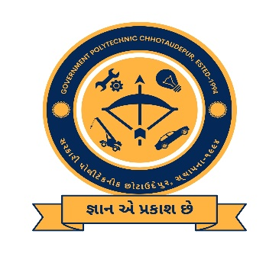

Date: 11/10/2022

Time: 11.30 AM

Venue: Government Polytechnic Chhotaudepur

Organize Awareness program on:

“Student Start-up research & Innovation festival Policy”

**Government Polytechnic, Chhotaudepur**

**SSIP Cell**

**(Under Directorate of Technical Education, Gujarat)**

Coordinators: Patron:

Mr. V. J. Pandya (SSIP coordinator, LEE) Mr. R.D.Parmar (I/c Principal, GP Chhotaudepur)

Mr. R.M. Kantharia (Asst SSIP coordinator LEE)

**All Branch & All Year Diploma students**